

DEPARTMENT OF ARTIFICIAL INTELLIGENCE AND DATA SCIENCE LAB MANUAL

AD23431 - STATISTICAL ANALYSIS AND COMPUTING
(REGULATION 2023)
RAJALAKSHMI ENGINEERING COLLEGE
Thandalam, Chennai-602015

Name: Manisha P
Register No: 231801096
Year / Branch / Section: 2nd / AI&DS / FA
Semester: IV
Academic Year: 2024 - 2025

INDEX
S.No. | Date | Title | Page No
1. | 05/2/25 | Implement Simple Programs in R | 3
2. | 19/2/25 | Perform Data Preprocessing in R | 9
3. | 05/3/25 | Perform Statistical Analysis for a Given Dataset | 12
4. | 26/3/25 | Implement Decision Tree Algorithm in R | 17
5. | 02/4/25 | Implement K-Nearest Neighbor Algorithm in R | 21
6. | 16/4/25 | Implement Naive Bayesian Classifier in R | 26
7. | 16/4/25 | Implement Linear Regression in R | 30
8. | 23/4/25 | Implement K-means Clustering Algorithm in R | 33

EXP NO: 1
IMPLEMENT SIMPLE PROGRAMS IN R

Aim:
To Implement Simple Programs using R.
Algorithm:
1. Basic Arithmetic Operations
a. Finding Area of Circle
- Input: Read radius r.
- Process: Calculate the area using the formula:
Area=π×r2\text{Area} = \pi \times r^2Area=π×r2
- Output: Print the calculated area.

2. Control Structures (if-else, for loop)
a. Check Whether the Given Year is Leap or Not
- Input: Read a year ly.
- Process:
  - If ly is divisible by 400, it’s a leap year.
  - Else, if divisible by 100 (but not by 400), it’s not a leap year.
  - Else, if divisible by 4, it’s a leap year.
  - Otherwise, it’s not a leap year.
- Output: Print whether the year is a leap year or not.

b. Reverse a Given Number
- Input: Read a number num.
- Process:
  - Initialize rev = 0.
  - While num > 0:
    - Extract last digit: ld = num % 10.
    - Update rev = rev * 10 + ld.
    - Remove last digit: num = num // 10.
- Output: Print the reversed number.

c. Finding Prime Numbers for the Given Range
- Input: Read the number n (upper limit).
- Process:
  - For each number i from 1 to n, check if it's prime:
    - If divisible by any number from 2 to √i, it’s not prime.
    - If no divisors found, it is prime.
- Output: Print all prime numbers from 1 to n.

3. Functions and Recursive Functions
a. Print the Fibonacci Sequence using Functions (Iterative)
- Input: Read n (number of terms in the sequence).
- Process:
  - Initialize first two terms: a = 0, b = 1.
  - Print a and b.
  - Loop (n-2) times:
    - Calculate next term c = a + b.
    - Update a = b, b = c.
  - Print the sequence of n terms.

b. Print the Fibonacci Sequence using Recursive Functions
- Input: Read n (number of terms in the sequence).
- Process:
  - Define a recursive function fibo(n):
    - If n == 0, return 0 (base case).
    - If n == 1, return 1 (base case).
    - Else, return fibo(n-1) + fibo(n-2).
  - Call fibo(i) for each i from 0 to n-1 and print the sequence.

Programs:
1. Basic Arithmetic Operations
a. Finding Area of Circle
r=as.integer(readline(("Enter the radius: ")))
area=pi*r*r
print(area)

Output:
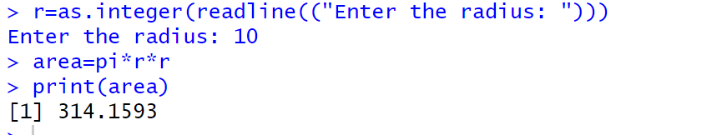

2. Control Structure (if-else, for loop)
a. To Check Whether the Given Year is Leap or Not
ly=as.integer(readline(("Enter a Number: ")))
if(ly%%400==0){
print("Leap Year")
}else if(ly%%100==0){
print("Not a Leap Year")
}else if(ly%%4==0){
print("Leap Year")
}else{
print("Not a Leap Year")
}
Output:
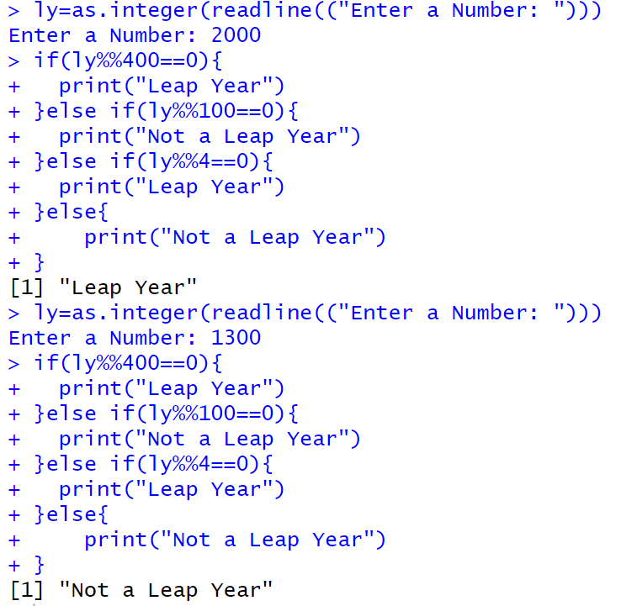

b. Reverse a Given Number
num=as.integer(readline("Enter a number: "))
rev=0
while(num>0){
ld=num%%10
rev=rev*10+ld
num=num%/%10
}
cat("Reversed NUmber",rev)

Output:
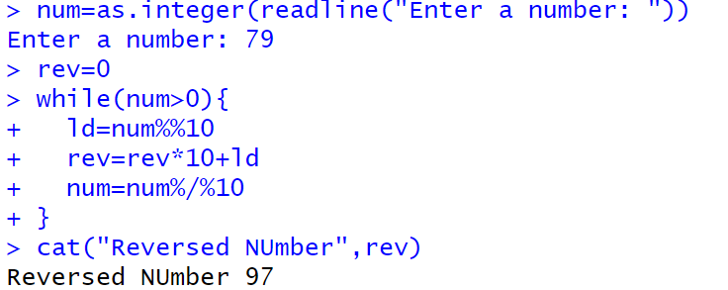

c. Finding Prime Numbers for the Given Range
prime<-function(n){
if(n<=1){
return (FALSE)}
for (i in 2:sqrt(n)){
if(n%%i==0){
return (FALSE)
}
}
return (TRUE)
}

n=as.integer(readline("Enter a number: "))
for (i in 1:n){
if(prime(i)){
print(i)
}
}

Output:
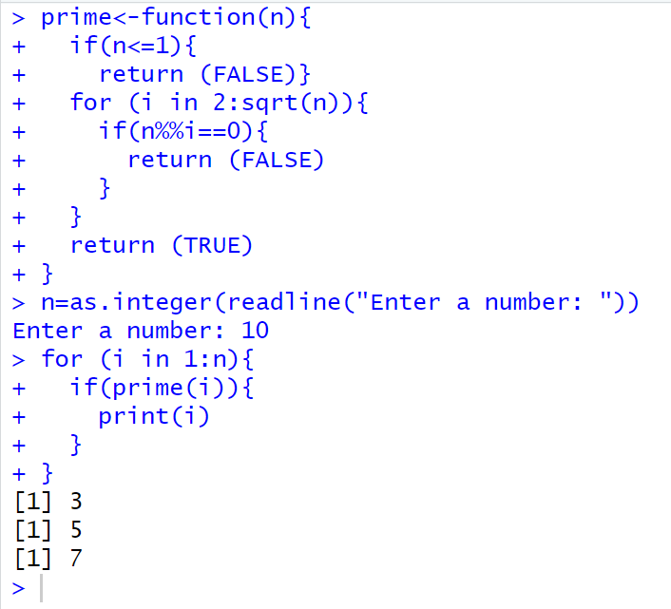

3. Functions and Recursive Functions
a. Print the Fibonacci Sequence using Functions
fibonacci_iterative <- function(n) {
fib_series <- numeric(n)
fib_series[1] <- 0
if (n > 1) fib_series[2] <- 1

for (i in 3:n) {
fib_series[i] <- fib_series[i-1] + fib_series[i-2]
}

return(fib_series)
}

n <- as.integer(readline("How many terms? "))
print(fibonacci_iterative(n))

Output:
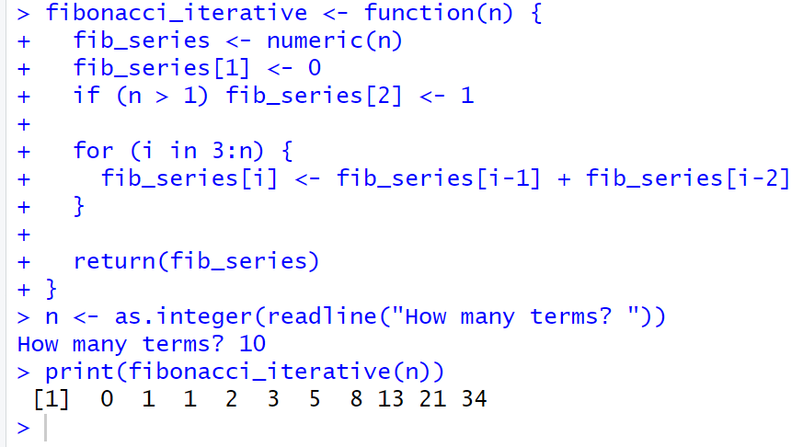

b. Print the Fibonacci Sequence using Recursive Functions
fibonacci_recursive <- function(n) {
if (n == 1) {
return(0)
} else if (n == 2) {
return(1)
} else {
return(fibonacci_recursive(n-1) + fibonacci_recursive(n-2))
}
}

n <- as.integer(readline("How many terms? "))
fib_series <- sapply(1:n, fibonacci_recursive)
print(fib_series)

Output:
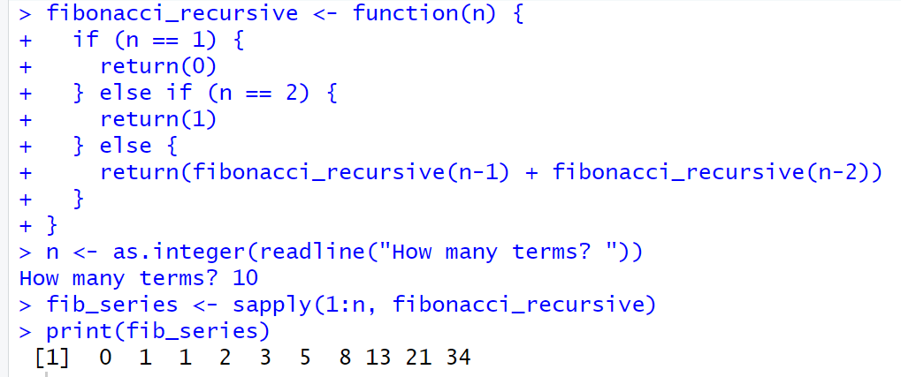

Result:
The Simple Program using R is Successfully Implemented.
EXP NO: 2
PERFORM DATA PREPROCESSING IN R

Aim:
To Perform Preprocessing of data using R.
Algorithm:
- Loading Data / Cleaning the Data:
  - Create emp_df2 with columns: emp_id, age, dept, salary, experience.
- Storing / Uploading Data to Excel Sheet:
  - Create a workbook wb, add a worksheet "Employee Data Preprocessing", and save emp_df2 to emp_df2.xlsx.
- Cleaning the Data:
  - Replace missing age and salary with their respective mean values.
  - Convert dept to numeric.
- Scaling the Data:
  - Scale the age, salary, and experience columns using z-score and update emp_df2.
- Splitting the Data into Train and Test:
  - Set seed, split data into 80% train and 20% test (dataTrain, dataTest).
- Correlation Matrix:
  - Compute the correlation matrix for the scaled features (age, salary, experience) to examine relationships between them.

Programs:
library(openxlsx)

emp_df2<-data.frame(
emp_id=1:10,
age=c(25,30,35,NA,55,65,NA,25,85,78),
dept=c("AI&DS","IT","AI&ML","CSE","PHY","FT","BIOTECH","CSBS","CIVIL","MECH"),
salary=c(50000,85100,52802,144510,552410,520000,445100,5552410,524160,NA),
experience=c(2,5,8,14,4,6,3,2,4,5)
)

wb<-createWorkbook()

addWorksheet(wb,"Employee Data Preprocessing")

writeData(wb,"Employee Data Preprocessing",emp_df2)

saveWorkbook(wb,"C:\\Users\\karthick.S\\OneDrive\\Documents\\231801079-4\\SAC\\emp_df2.xlsx",overwrite = TRUE)

emp_df2$age[is.na(emp_df2$age)]<-floor(mean(emp_df2$age,na.rm = TRUE))

emp_df2$salary[is.na(emp_df2$salary)]<-floor(mean(emp_df2$salary,na.rm = TRUE))

emp_df2$dept<-as.numeric(as.factor(emp_df2$dept))

emp_df_scaled<-scale(emp_df2[,c("age","salary","experience")])
emp_df2<-data.frame(emp_df2[,c("emp_id","dept")],emp_df_scaled)

correlation_matrix <- cor(emp_df2[, c("age", "salary", "experience")])
print("Correlation Matrix:")
print(correlation_matrix)

set.seed(42)
trainIndex<-sample(1:nrow(emp_df2),0.8*nrow(emp_df2))
dataTrain<-emp_df2[trainIndex,]
dataTest<-emp_df2[-trainIndex,]

print(dataTrain)
print(dataTest)

Output:
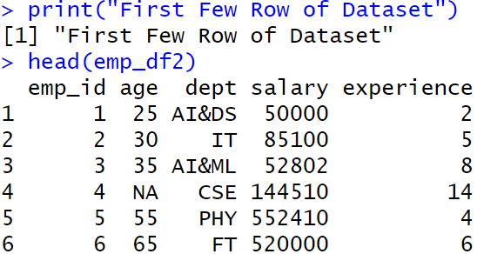
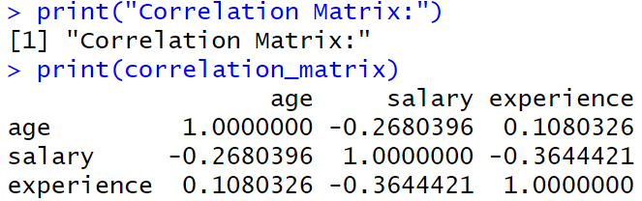
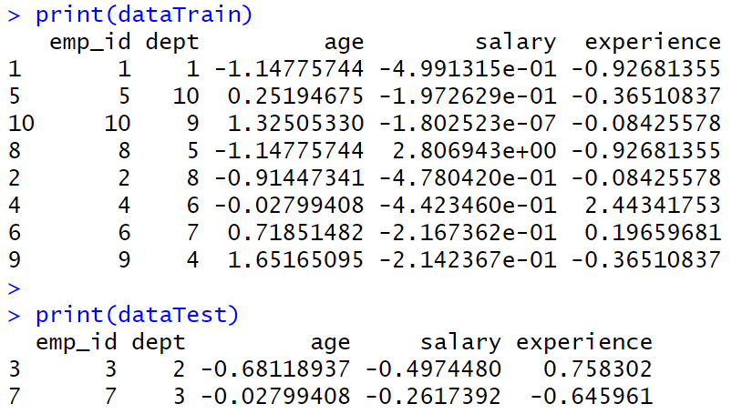

Result:
Thus, Preprocessing data is cleaned, transformed and formatted dataset ready for analysis or modelling.
EXP NO: 3
PERFORM STATISTICAL ANALYSIS FOR A GIVEN DATASET

Aim:
To Perform Statistical Analysis for Given Dataset.
Algorithm:
1. Loading Libraries:
- Load the necessary libraries: dplyr, summarytools, psych.
2. Loading Data:
- Create a dataset data with columns Age and Salary.
3. Statistical Analysis:
- Mean: Calculate the mean of Age.
- Median: Calculate the median of Age.
- Mode: Calculate the mode of Age using the table function.
- Variance: Calculate the variance of Age.
- Standard Deviation: Calculate the standard deviation of Age.
- Correlation: Calculate the correlation between Age and Salary.
4. Descriptive Statistics:
- Use the summary() function to generate summary statistics for the dataset.
5. Quantile Analysis:
- Calculate the quantiles for both Age and Salary.
6. Interquartile Range (IQR):
- Calculate the IQR for both Age and Salary.
7. Hypothesis Testing (T-Test):
- Perform a one-sample t-test on Salary with a hypothesized mean of 70,000.
8. Visualization:
- Boxplot: Create a boxplot for Age and Salary to visualize their distributions.
9. Detailed Descriptive Statistics:
- Use describe() from the psych package to get detailed statistics for Age and Salary.
- Use descr() from the summarytools package for detailed descriptive statistics.

Program:
library(dplyr)
library(summarytools)
library(psych)

data <- data.frame(Age = c(25, 30, 28, 35, 40, 45, 50, 32, 38, 42),
Salary = c(50000, 60000, 55000, 75000, 80000, 85000, 90000, 65000, 78000, 82000))
cat("Dataset:\n")
print(data)

mean_age <- mean(data$Age)
median_age <- median(data$Age)
mode_age <- as.numeric(names(sort(table(data$Age), decreasing = TRUE))[1])

var_age <- var(data$Age)
sd_age <- sd(data$Age)

corr <- cor(data$Age, data$Salary)

cat("\nStatistical Analysis Results:\n")
print(mean_age)
print(median_age)
print(mode_age)
print(var_age)
print(sd_age)
print(corr)

data_summary <- summary(data)
print(data_summary)

quantile_age <- quantile(data$Age)
quantile_salary <- quantile(data$Salary)

IQR_age <- IQR(data$Age)
IQR_salary <- IQR(data$Salary)

cat("Quantile Age", quantile_age)
cat("\nQuantile Salary", quantile_salary)

cat("\nIQR Age", IQR_age)
cat("\nIQR Salary", IQR_salary)

t_test_result <- t.test(data$Salary, mu = 70000)
print(t_test_result)

boxplot(data$Age, main = "Boxplot of Age", ylab = "Age", col = "lightblue")
boxplot(data$Salary, main = "Boxplot of Salary", ylab = "Salary", col = "lightgreen")

cat("\nDescribe Method From Describe of psych")
descr_stats <- describe(data[, c("Age", "Salary")])
print("Detailed Descriptive Statistics:")
print(descr_stats)
cat("\nDescribe Method From Descr of SummaryTools")
print(descr(data))
Output:
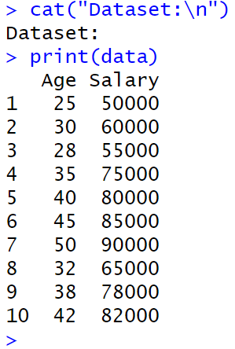

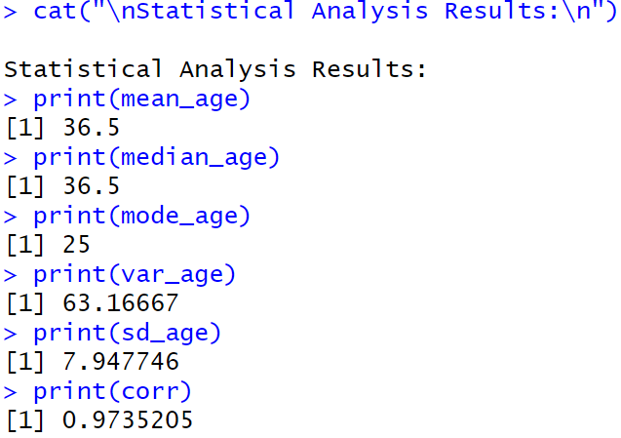
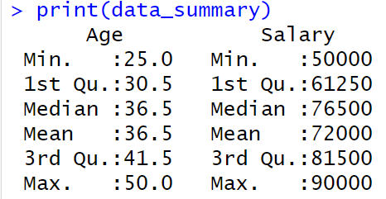
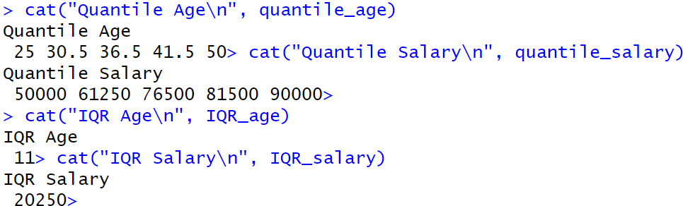

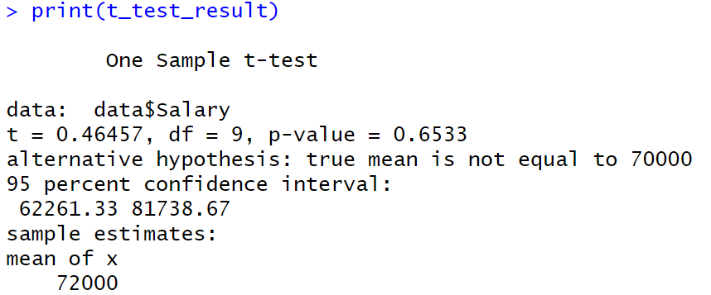
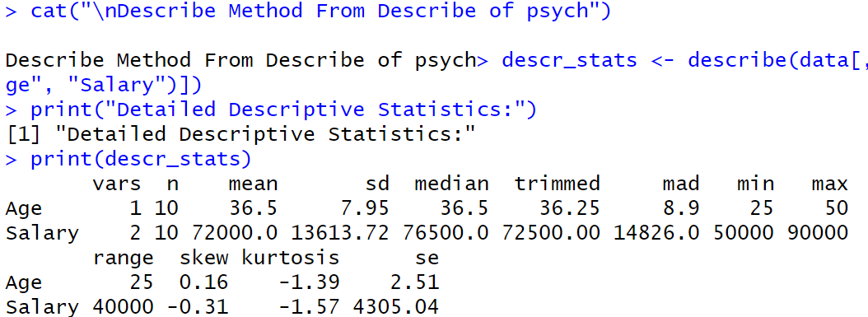
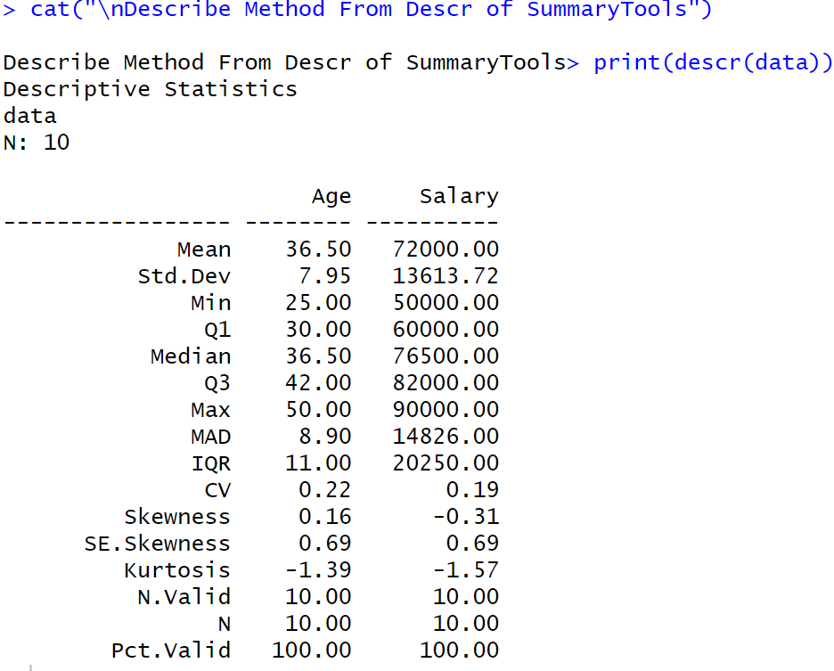
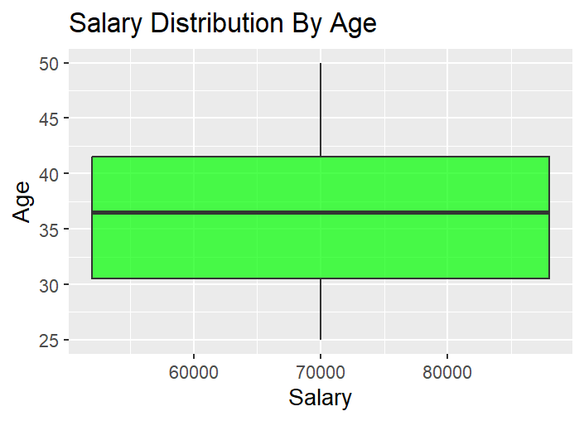
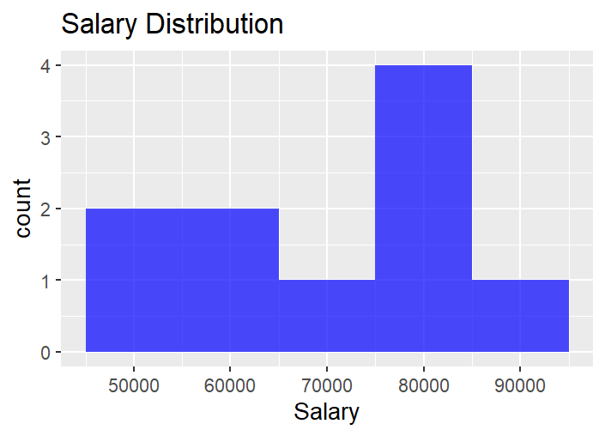

Result:
Thus, Statistical Analysis for a Given Dataset using is Analysed and Scaled.

EXP NO: 4
IMPLEMENT DECISION TREE ALGORITHM IN R

Aim:
Implement a Decision Tree Classification on the Given Dataset.

Procedure:
1. Load Required Libraries
- Load the necessary libraries:
  - rpart for building decision tree models.
  - rpart.plot for visualizing decision trees.
  - caret for data splitting and model evaluation.
Code:
library(rpart)
library(rpart.plot)
library(caret)

2. Load the Dataset
- Load the Iris dataset (built-in in R).
- Display the first few rows to understand the data structure.
Code:
data("iris")
print("First Few Rows of Dataset")
head(iris)

3. Split the Data into Training and Testing Sets
- Set a seed for reproducibility.
- Use createDataPartition to split the data into:
  - 80% training set
  - 20% testing set
Code:
set.seed(123)
train_index <- createDataPartition(iris$Species, p = 0.8, list = FALSE)
train_data <- iris[train_index, ]
test_data <- iris[-train_index, ]

4. Train a Decision Tree Model
- Build a decision tree classifier using rpart, predicting Species based on the features.
Code:
tree_model <- rpart(Species ~ ., data = train_data, method = "class")
print(tree_model)

5. Visualize the Decision Tree
- Plot the trained decision tree using rpart.plot with enhanced formatting.
Code:
rpart.plot(tree_model,
main = "Decision Tree for Iris Dataset",
type = 3,
extra = 101,
under = TRUE,
tweak = 1.2,
box.palette = "RdBu")

6. Make Predictions on Test Data
- Use the trained model to predict the species on the test dataset.
Code:
pred <- predict(tree_model, test_data, type = "class")

7. Evaluate Model Performance
- Create a confusion matrix to compare predicted vs actual labels.
- Print evaluation metrics like accuracy, sensitivity, specificity, etc.
Code:
conf_mat <- confusionMatrix(pred, test_data$Species)
print(conf_mat)

Output:
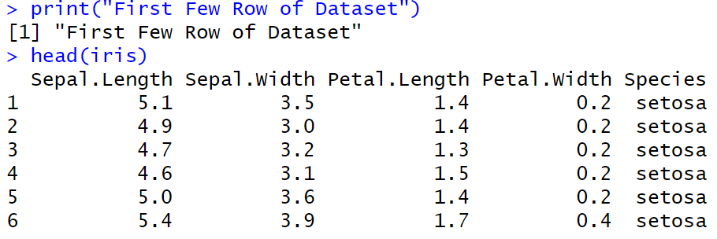

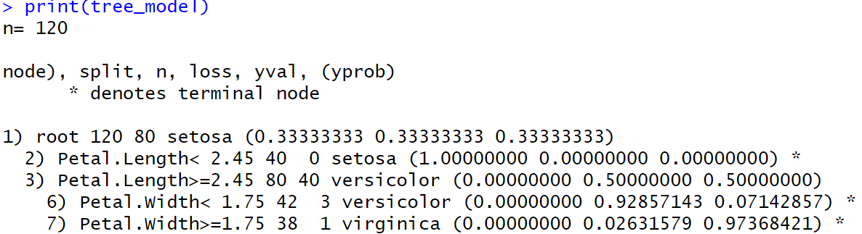

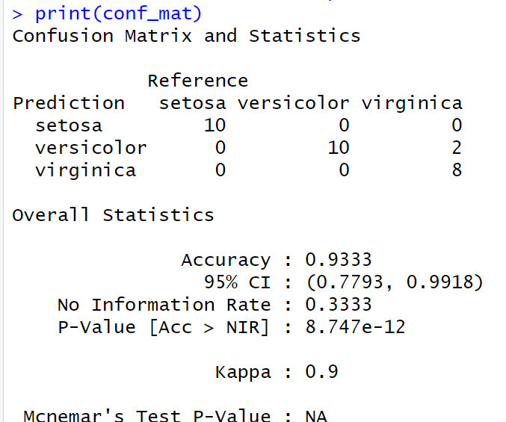

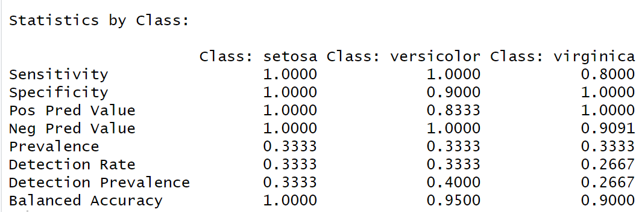
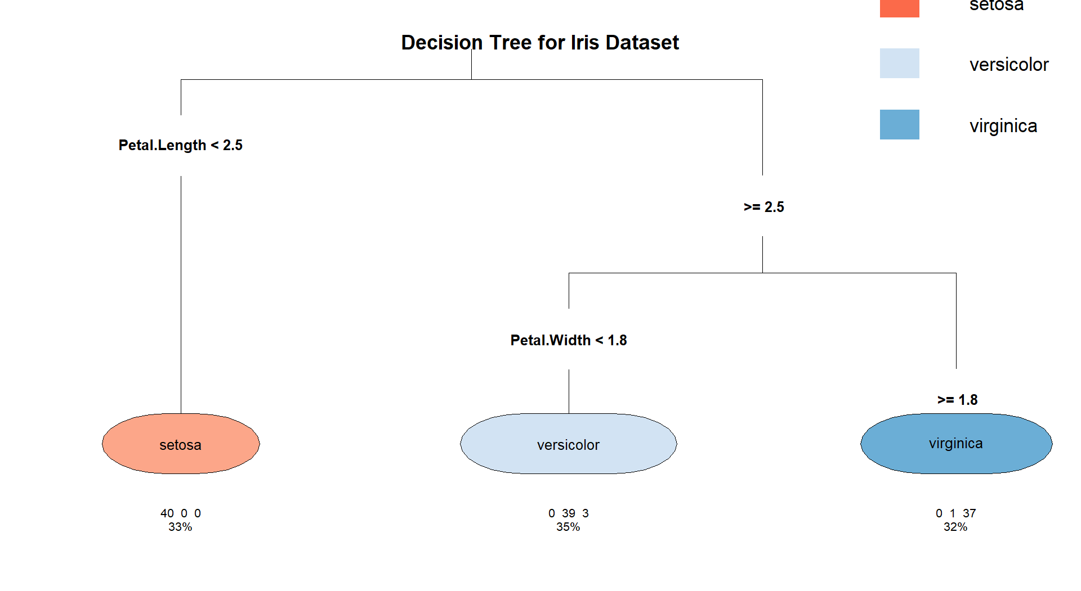

Result:
The Decision Tree is Implemented Successfully.

EXP NO: 5
IMPLEMENT K-NEAREST NEIGHBOR ALGORITHM IN R

Aim:
Implement a KNN Classification on the Given Dataset.
Procedure:
1. Load Required Libraries
- Load the necessary libraries:
  - class for KNN model.
  - ggplot2 for plotting.
  - GGally for advanced plots (pairwise plots).
  - caret for data partitioning and evaluation.
Code:
library(class)
library(ggplot2)
library(GGally)
library(caret)

2. Load the Dataset
- Load the Iris dataset.
- Display the first few rows to understand the structure.
Code:
data("iris")
print("First Few Rows of Dataset")
head(iris)

3. Define a Normalize Function
- Create a custom function to normalize (scale between 0 and 1) the numerical feature columns.
Code:
normalize <- function(x) {
return((x - min(x)) / (max(x) - min(x)))
}

4. Normalize the Feature Columns
- Apply the normalization function to the first four feature columns.
- Add back the Species column separately.

Code:
iris_norm <- as.data.frame(lapply(iris[1:4], normalize))
iris_norm$Species <- iris$Species

5. Split the Data into Training and Testing Sets
- Set a random seed for reproducibility.
- Use createDataPartition to split:
  - 80% for training
  - 20% for testing
Code:
set.seed(123)
train_index <- createDataPartition(iris$Species, p = 0.8, list = FALSE)
train_data <- iris_norm[train_index, ]
test_data <- iris_norm[-train_index, ]
6. Extract Training and Test Labels
- Separate the labels (Species) from the feature data for both train and test sets.
Code:
train_labels <- train_data$Species
test_labels <- test_data$Species

7. Train the KNN Model
- Train the K-Nearest Neighbors model using:
  - Normalized feature columns
  - k = 5 neighbors.
Code:
knn_model <- knn(train = train_data[, 1:4], test = test_data[, 1:4], cl = train_labels, k = 5)
print(knn_model)

8. Visualize the Data
- Create visualizations to understand feature distributions:
  - Scatter plot of Sepal Length vs Sepal Width.
  - Pairwise plots (all feature combinations).
Code:
ggplot(data = iris, aes(x = Sepal.Length, y = Sepal.Width, color = Species)) +
geom_point() +
labs(title = "Scatter Plot of Sepal Dimensions", x = "Sepal Length", y = "Sepal Width") +
theme_minimal()
ggpairs(iris, aes(color = Species)) +
theme_minimal()

9. Evaluate Model Performance
- Generate a confusion matrix comparing predictions and true labels.
- Print classification results including accuracy, sensitivity, and specificity.
Code:
conf_mat <- confusionMatrix(knn_model, test_labels)
print(conf_mat)

Output:
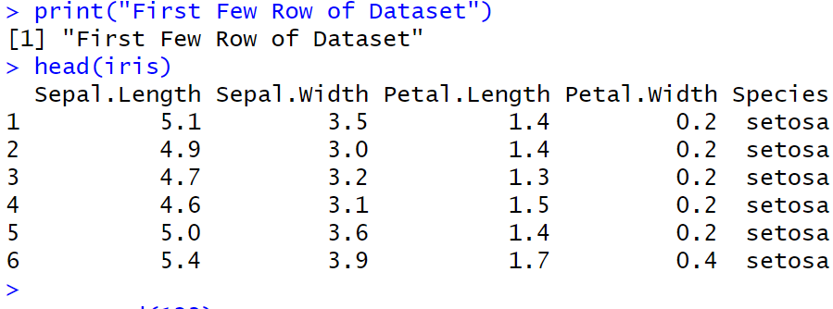
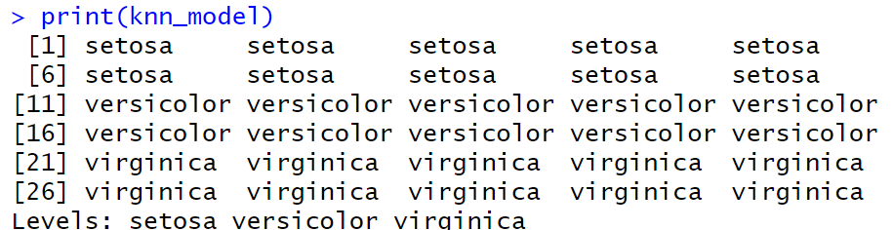
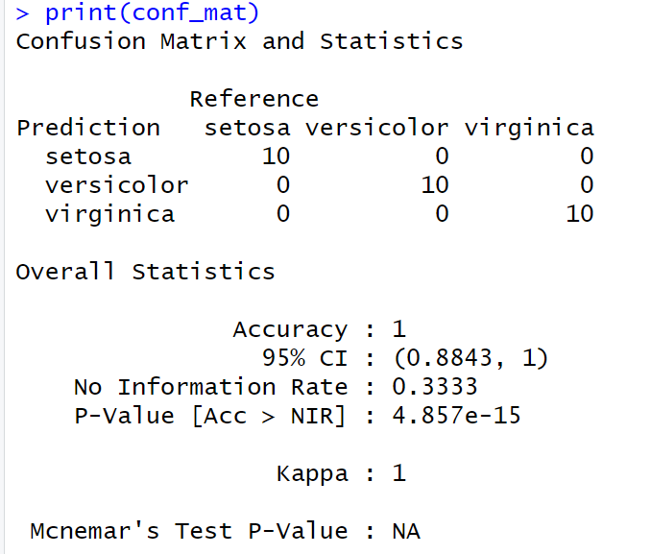

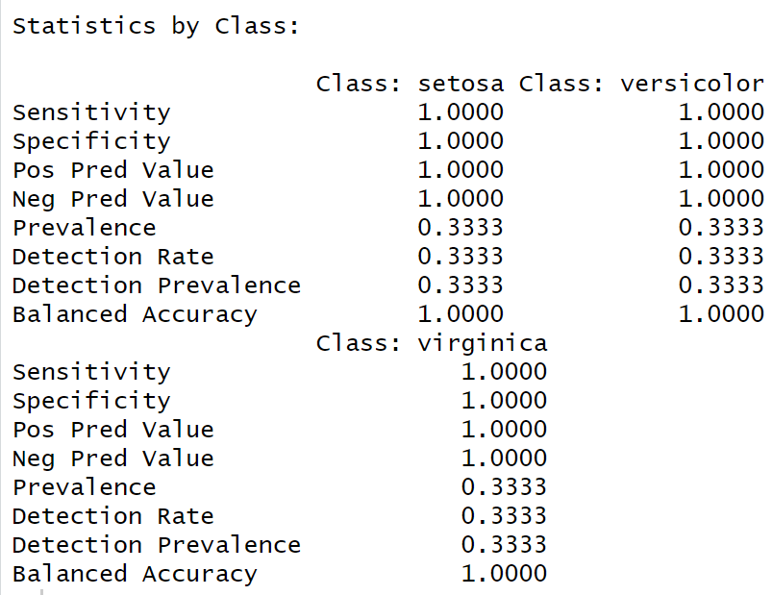
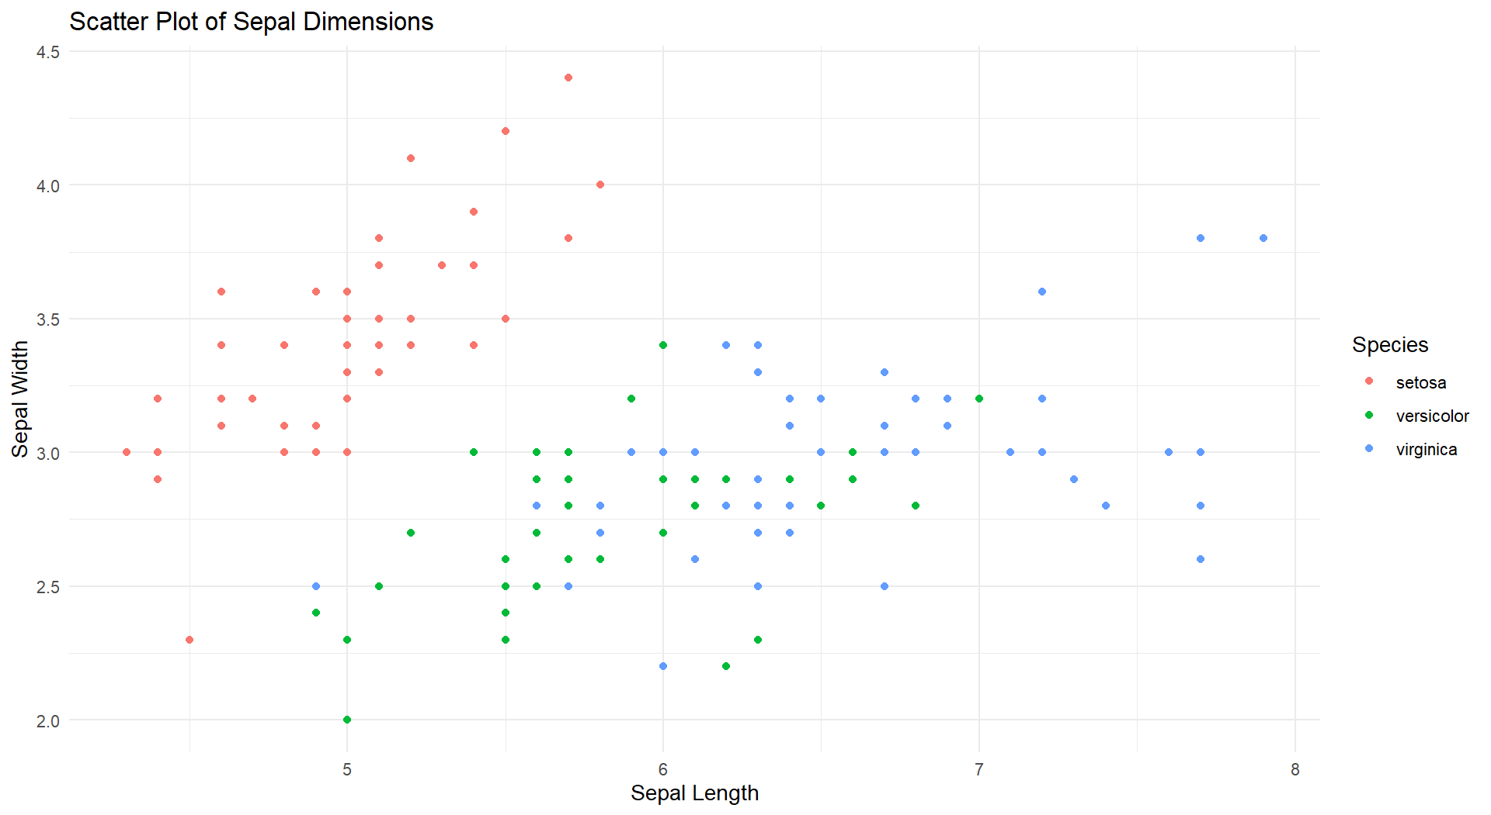
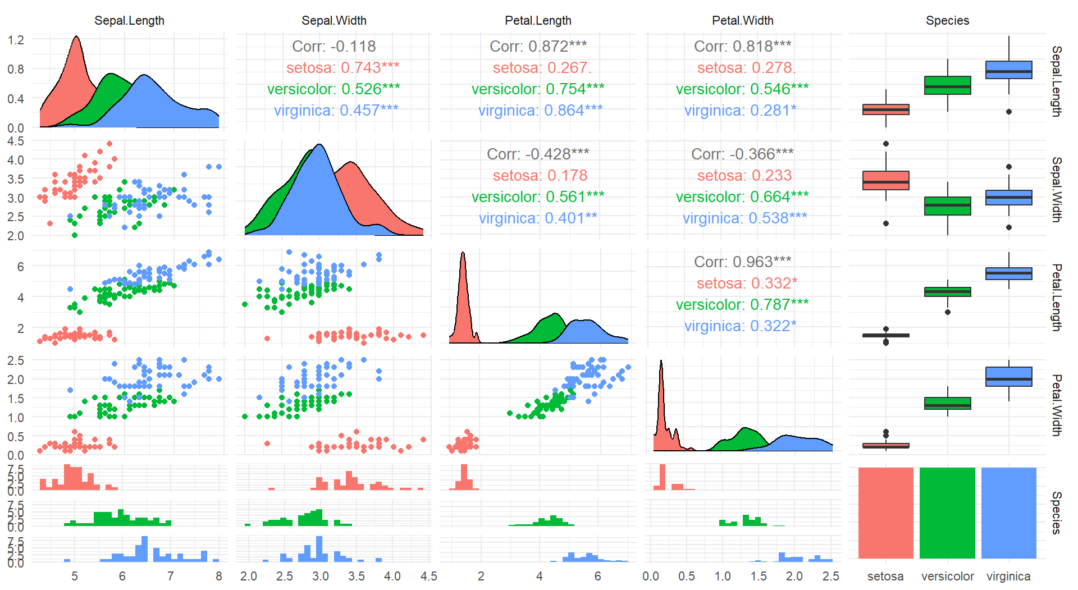

Result:
The KNN Classification is Successfully Implemented.
EXP NO: 6
IMPLEMENT NAIVE BAYESIAN CLASSIFIER IN R

Aim:
Implement a Naïve Bayes Classification on the Given Dataset.
Procedure:
1. Load Required Libraries
- Load the necessary libraries:
  - e1071 for the Naive Bayes model.
  - ggplot2 for visualization.
  - caret for data partitioning and evaluation.
Code:
library(e1071)
library(ggplot2)
library(caret)

2. Load the Dataset
- Load the Iris dataset.
- Display the first few rows for a quick overview.
Code:
data("iris")
print("First Few Rows of Dataset")
head(iris)

3. Split the Data into Training and Testing Sets
- Set a random seed to ensure reproducibility.
- Split the data into:
  - 80% for training
  - 20% for testing
Code:
set.seed(123)
train_index <- createDataPartition(iris$Species, p = 0.8, list = FALSE)
train_data <- iris[train_index, ]
test_data <- iris[-train_index, ]

4. Extract Training and Test Labels
- Assign the Species column as the labels for training and testing.
Code:
train_labels <- train_data$Species
test_labels <- test_data$Species

5. Train the Naive Bayes Model
- Train the Naive Bayes classifier using the training data.
Code:
nb_model <- naiveBayes(Species ~ ., data = train_data)
print(nb_model)

6. Visualize the Data
- Create a scatter plot of Sepal Length vs Sepal Width colored by species.
Code:
ggplot(data = iris, aes(x = Sepal.Length, y = Sepal.Width, color = Species)) +
geom_point() +
labs(title = "Scatter Plot of Sepal Dimensions", x = "Sepal Length", y = "Sepal Width") +
theme_minimal()

7. Make Predictions on the Test Data
- Predict the species for the test dataset using the trained model.
Code:
pred <- predict(nb_model, test_data)

8. Evaluate Model Performance
- Generate a confusion matrix to compare the predicted labels and true labels.
- Print evaluation metrics like accuracy, sensitivity, and specificity.
Code:
conf_mat <- confusionMatrix(pred, test_labels)
print(conf_mat)

Output:
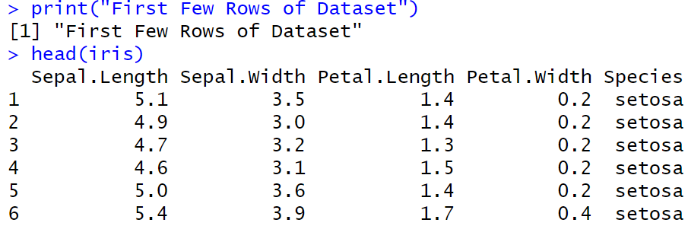
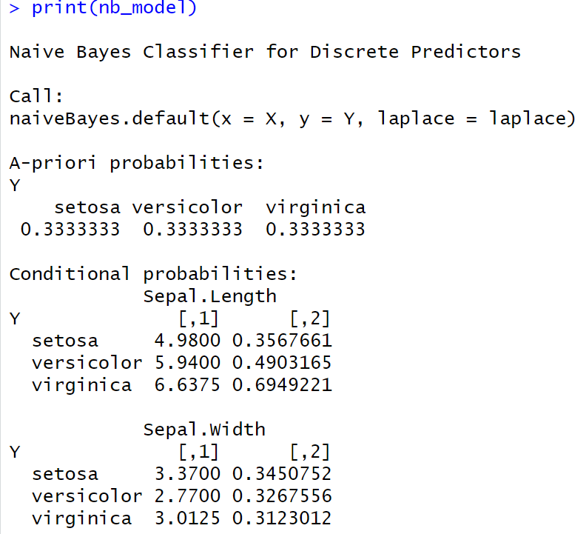
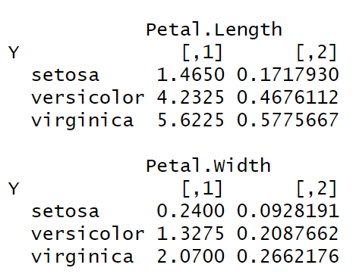
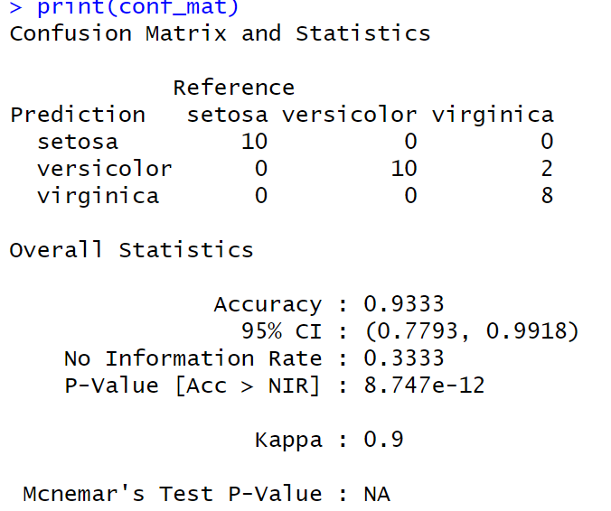
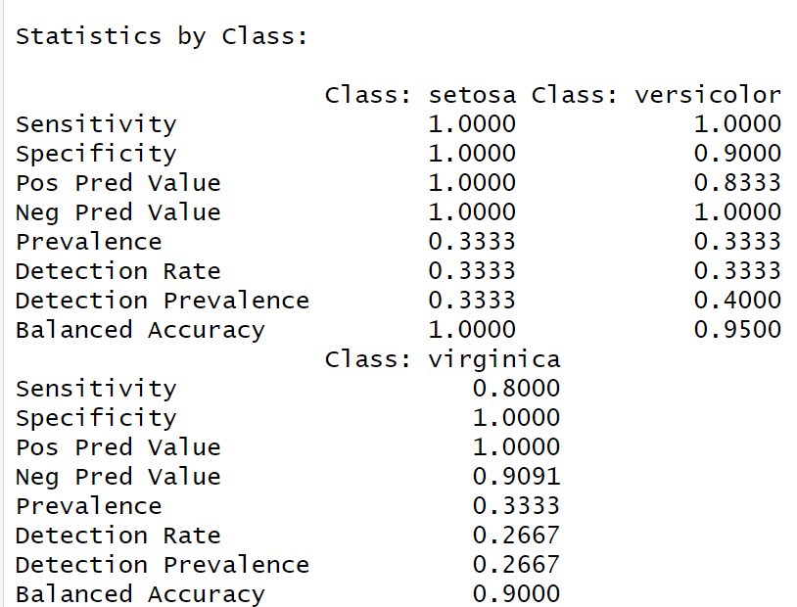


Result:
The Naïve Bayes Classification is Successfully Implemented.

EXP NO: 1
Title
EXP NO: 7
IMPLEMENT LINEAR REGRESSION IN R

Aim:
Implement a Linear Regression on the Given Dataset.
Procedure:
1. Load Required Libraries
- Load the necessary libraries:
  - ggplot2 for visualization.
  - caret for splitting the data and evaluating the model.
Code:
library(ggplot2)
library(caret)

2. Load the Dataset
- Load the Headbrain dataset from a CSV file.
- Display the first few rows to inspect the data.
Code:
df <- read.csv("C:/Users/karthick.S/OneDrive/Documents/231801079-4/SAC/headbrain.csv")
print("First Few Rows of Dataset")
head(df)

3. Split the Data into Training and Testing Sets
- Set a random seed for reproducibility.
- Split the data into:
  - 70% for training
  - 30% for testing
Code:
set.seed(123)
index <- createDataPartition(df$Brain.Weight.grams., p = 0.7, list = FALSE)
train <- df[index, ]
test <- df[-index, ]

4. Train the Linear Regression Model
- Train a linear regression model to predict Brain.Weight.grams. based on Head.Size.cm.3..
Code:
print("Linear Regression Model")
model <- lm(Brain.Weight.grams. ~ Head.Size.cm.3., data = train)
print(model)
5. Make Predictions on the Test Data
- Use the trained model to predict brain weight values for the test dataset.
Code:
pred <- predict(model, newdata = test)

6. Evaluate Model Performance
- Use postResample to calculate evaluation metrics:
  - RMSE (Root Mean Squared Error)
  - R-squared (Coefficient of Determination)
  - MAE (Mean Absolute Error)
Code:
evaluation <- postResample(pred, test$Brain.Weight.grams.)
cat("RMSE:", evaluation["RMSE"], "\n")
cat("R-squared:", evaluation["Rsquared"], "\n")
cat("MAE:", evaluation["MAE"], "\n")

7. Visualize the Data
- Plot the scatter points of the original data.
- Overlay the regression line based on the model’s predictions.
Code:
x_vals <- seq(min(df$Head.Size.cm.3.) - 100, max(df$Head.Size.cm.3.) + 100, length.out = 1000)
pred_line <- data.frame(Head.Size.cm.3. = x_vals)
pred_line$Brain.Weight.grams. <- predict(model, newdata = pred_line)

plot(df$Head.Size.cm.3., df$Brain.Weight.grams.,
col = "green", pch = 19,
xlab = "Head Size (cm³)",
ylab = "Brain Weight (grams)",
main = "Head Size vs Brain Weight with Regression Line")

lines(pred_line$Head.Size.cm.3., pred_line$Brain.Weight.grams., col = "red", lwd = 2)

Output:
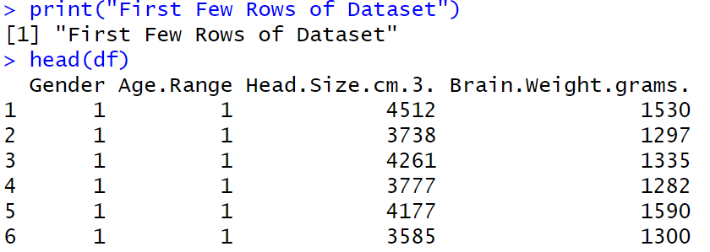

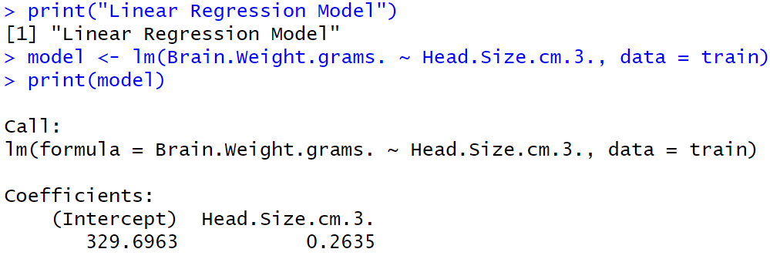
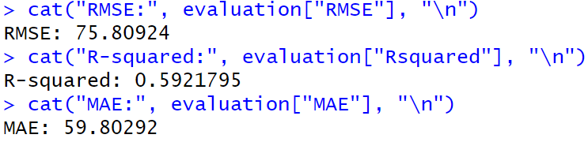
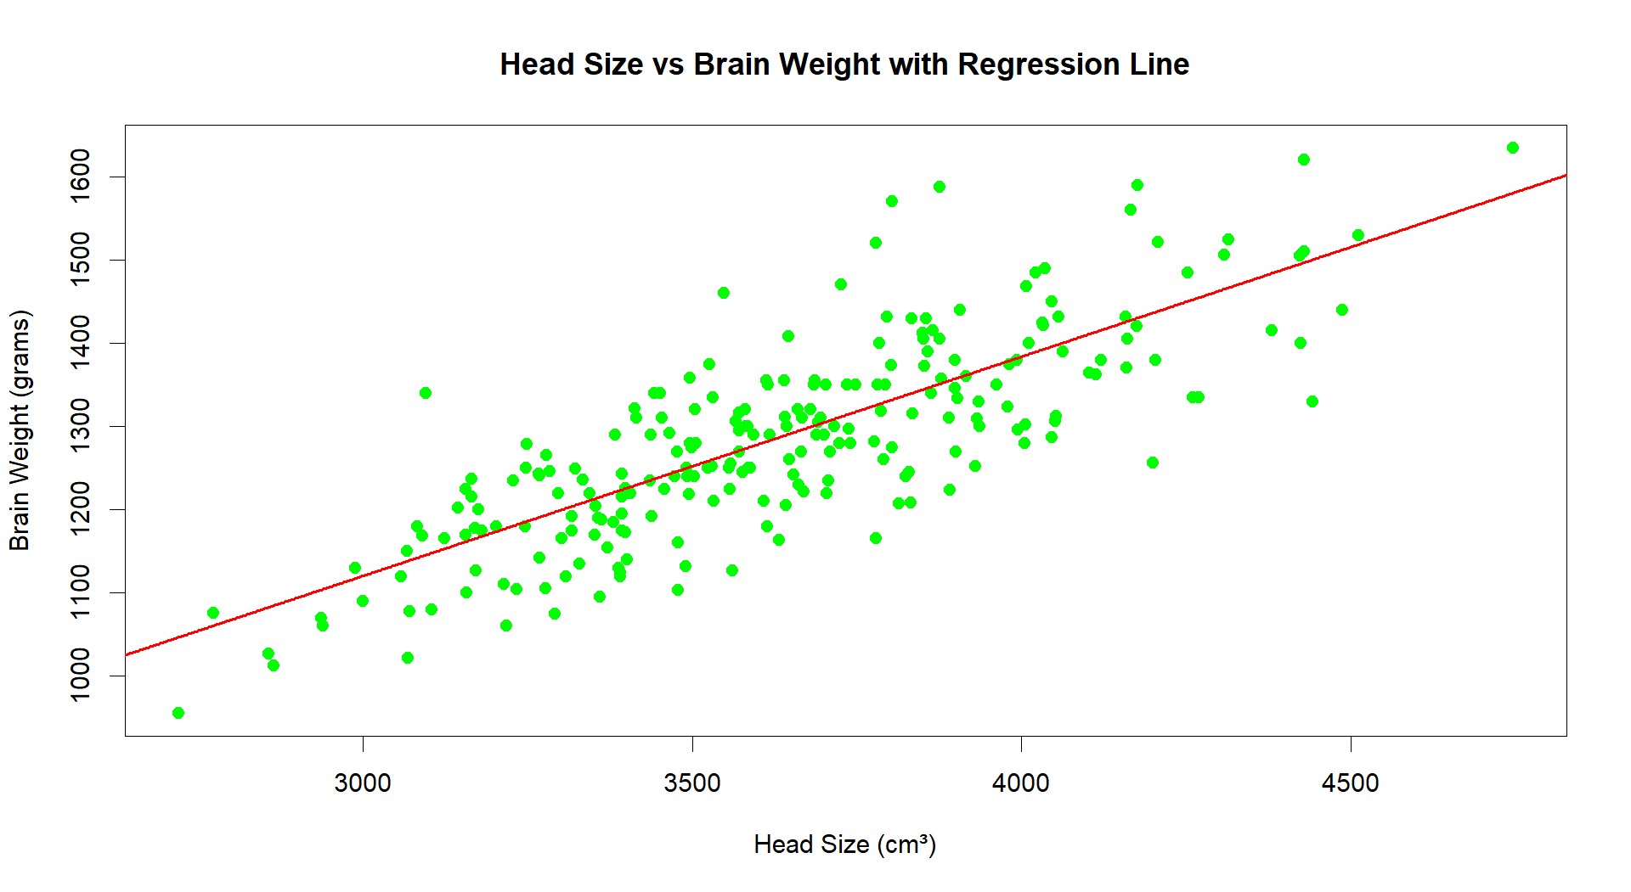

Result:
The Linear Regression is Successfully Implemented.
EXP NO: 8
IMPLEMENT K-MEANS CLUSTERING ALGORITHM IN R

Aim:
Implement a Kmeans Clustering on the Given Dataset.
Procedure:
Procedure for Performing and Evaluating K-means Clustering in R
1. Load Required Libraries
- Load the necessary libraries:
  - ggplot2 for plotting.
  - cluster for silhouette analysis.
  - factoextra for easy visualization of clustering.
Code:
library(ggplot2)
library(cluster)
library(factoextra)

2. Load the Dataset
- Load the Iris dataset.
- Remove the Species column to focus only on the numeric features for clustering.
Code:
data(iris)
iris_data <- iris[, -5]
head(iris_data)

3. Determine the Optimal Number of Clusters Using Elbow Method
- Use the Within-Cluster Sum of Squares (WSS) method to decide how many clusters are appropriate.
Code:
fviz_nbclust(iris_data, kmeans, method = "wss") +
ggtitle("Elbow Method for Optimal K")

4. Apply K-means Clustering with 3 Clusters
- Set a random seed for reproducibility.
- Apply K-means clustering specifying 3 clusters (since Iris has 3 species).
Code:
set.seed(123)
kmeans_model <- kmeans(iris_data, centers = 3, nstart = 25)

5. Print Cluster Centers and Cluster Assignments
- View the center points of the clusters and how the data points were assigned.
Code:
print(kmeans_model$centers)
print(kmeans_model$cluster)

6. Visualize the Clusters
- Visualize the clustering result using a scatter plot with convex hulls around clusters.
Code:
fviz_cluster(kmeans_model, data = iris_data, geom = "point", ellipse.type = "convex") +
ggtitle("K-means Clustering on Iris Dataset")

7. Evaluate the Clustering (Silhouette Analysis)
- Perform silhouette analysis to assess the quality of the clustering.
Code:
silhouette_score <- silhouette(kmeans_model$cluster, dist(iris_data))
fviz_silhouette(silhouette_score)

Output:
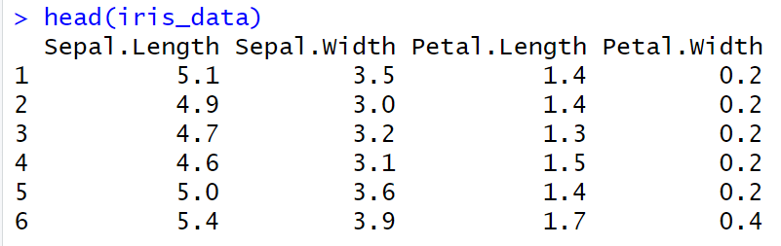
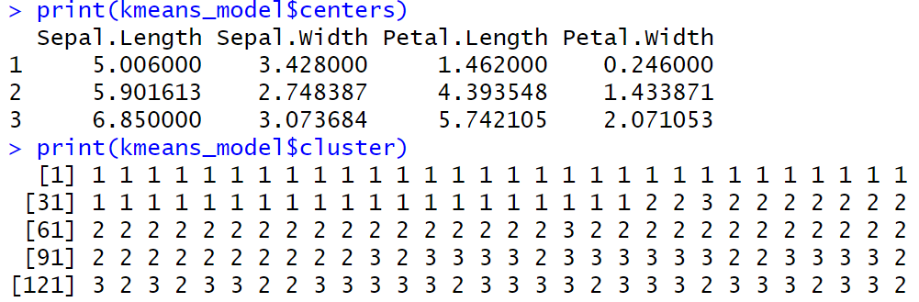
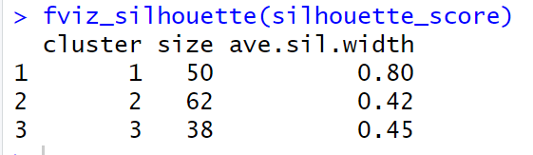

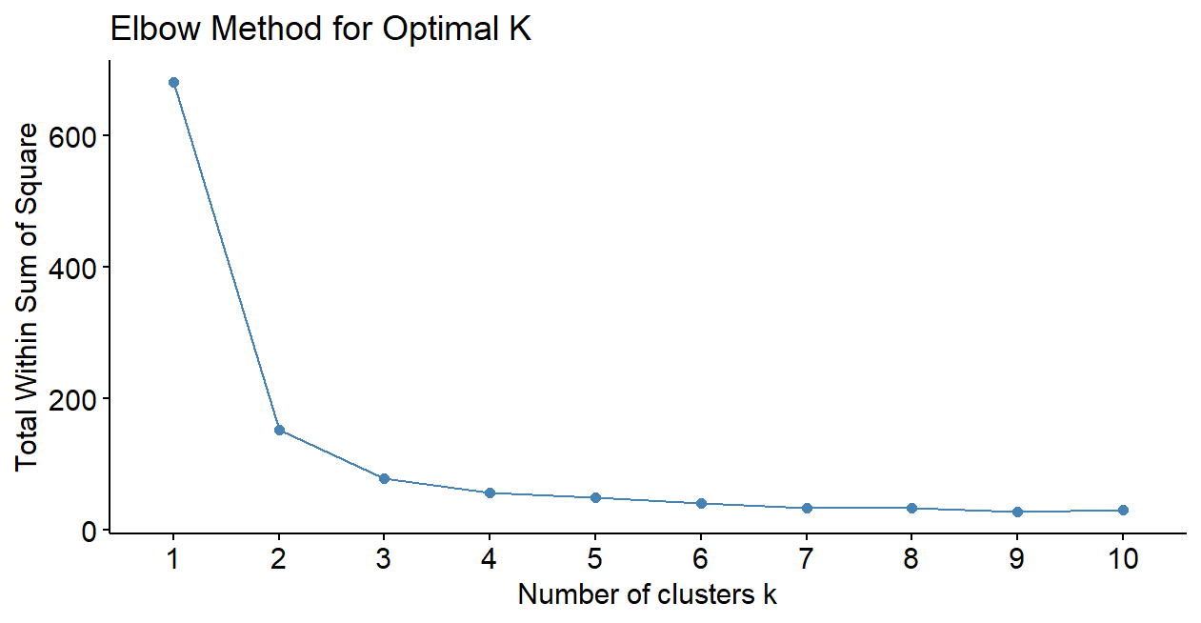
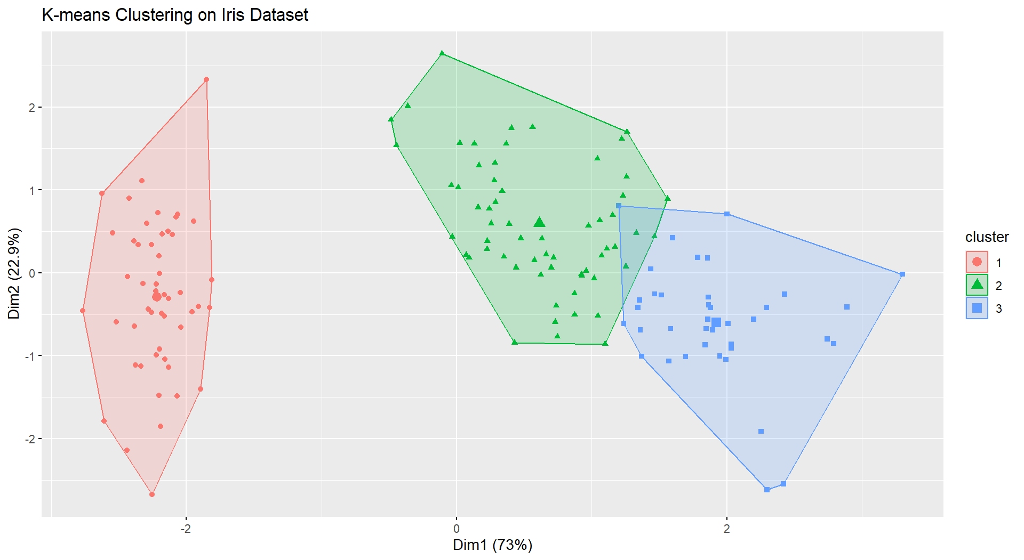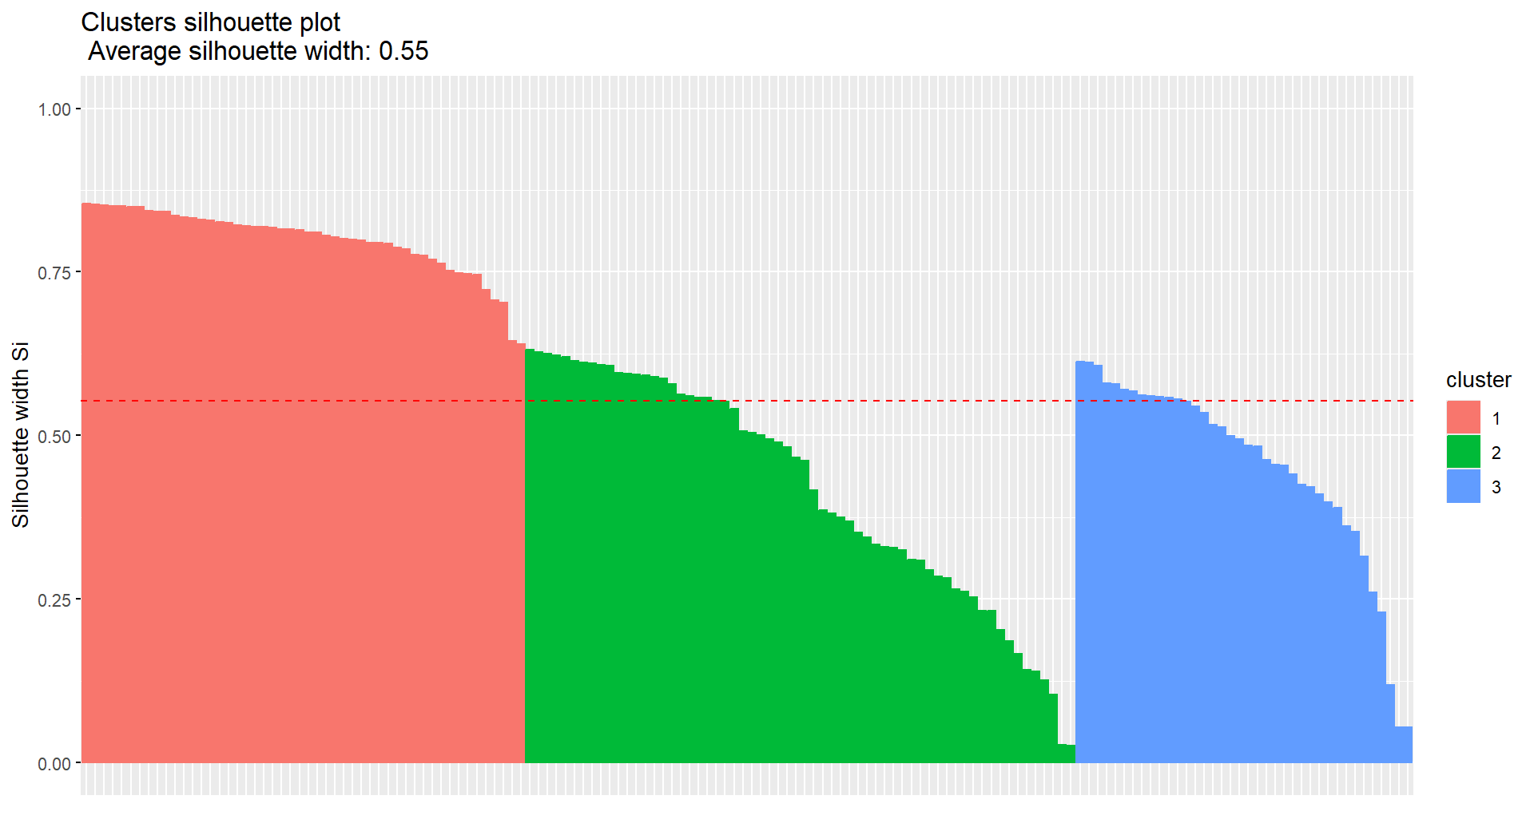

Result:
The Kmeans is Successfully Implemented.

